**Exercise 2: TDD Feature Implementation**

### **Objective:** Develop a simple calculator in Javascript that performs addition, subtraction, multiplication, and division by writing tests first.

## **Step-by-Step Instructions**

### **Define Your Feature**

* 1. **Decide on the Functionality:**
     1. You will implement functions for adding, subtracting, multiplying, and dividing two numbers.

### **Write Your Test Cases First**

* 1. Open the file index.test.js that you created in Exercise 1.
  2. Add a comment to describe your test:

| // Test for calculator functions |
| --- |

* 1. Write a Test for Addition:

| **test('adds 2 + 3 to equal 5', () => {  expect(add(2, 3)).toBe(5); });** |
| --- |

* 1. Type the following code (you can let Copilot suggest improvements):
  2. Repeat for Other Operations:

Type comments such as:

| // TODO: Write tests for subtract, multiply, and divide functions |
| --- |

Allow Copilot to suggest complete tests if available.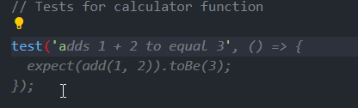

* 1. Save the test file.

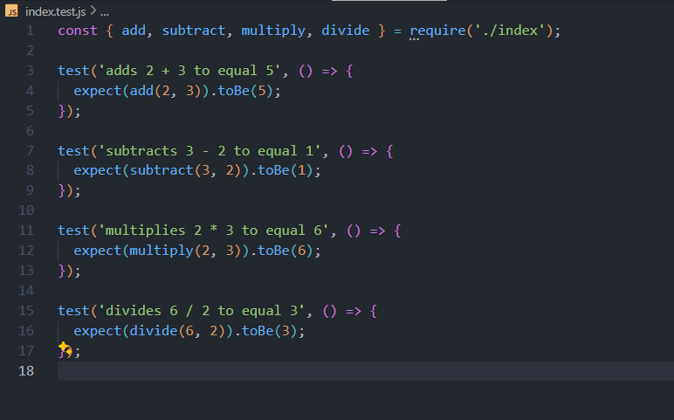

### **Implement the Feature in index.js**

* 1. Open index.js.
  2. Write the Addition Function:  
     Begin with a comment:

| // Function to add two numbers |
| --- |

* 1. Then type the function signature:

| function add(a, b) {  return a + b; } |
| --- |

GitHub Copilot may suggest further details; accept or modify as needed.

* 1. **Implement the Other Functions:**
     1. Similarly add functions for subtraction, multiplication, and division:

| function subtract(a, b) {  return a - b; }  function multiply(a, b) {  return a * b; }  function divide(a, b) {  if(b === 0) {  throw new Error("Cannot divide by zero");  }  return a / b; }  // Export functions for testing (if using modules) module.exports = { add, subtract, multiply, divide }; |
| --- |

* 1. Save the file.

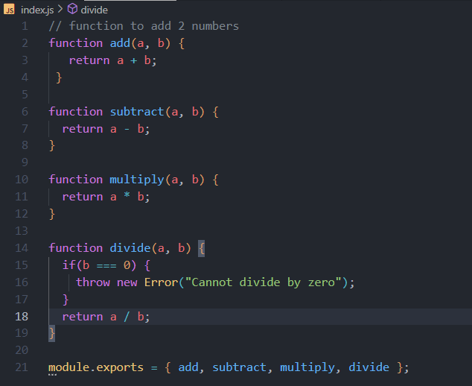

### **Run Your Tests**

* 1. Create a package.json file and add jest in it:

{

"scripts": {

"test": "jest" }

}

* 1. Open the terminal.
  2. Run your tests using a tool such as jest. For example:

| npm test |
| --- |

* 1. Ensure all tests pass. If a test fails, review the suggestions from Copilot and adjust your code accordingly.

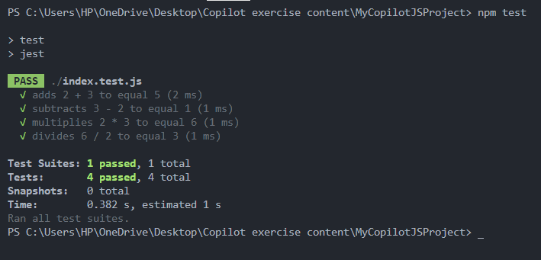

### **(Optional) Commit Your Changes**

* 1. In the terminal, run:

| git add . git commit -m "Implemented calculator functions using TDD in Javascript" |
| --- |

Voila!! We have successfully completed this exercise.